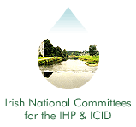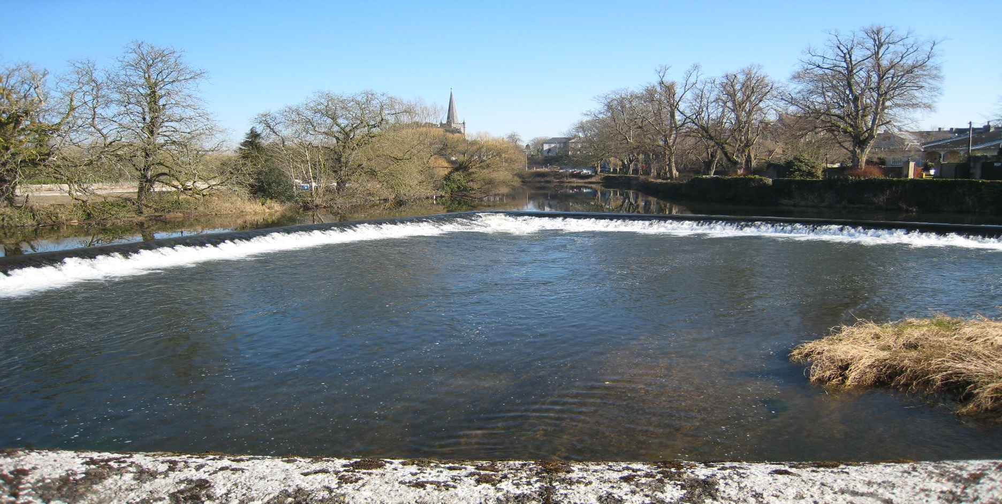
Irish National Hydrology
Conference 2017

First Announcement
Call for Papers & Posters

Tuesday, 21st November 2017

Hodson Bay Hotel

Athlone, Co. Roscommon

Introduction
The National Committees of the IHP/ICID invite you to Athlone for the 18th National Hydrology Conference to be held on Tuesday 21st November 2017 at the Hodson Bay Hotel. This event is Ireland's leading Conference devoted to Hydrology providing a unique forum for attendees to share policy developments, research results, and practical solutions to engineering hydrology issues.

Main Topics ..
It is important that Hydrological Conferences continue to play important roles in disseminating operational hydrology and hydrological research to practitioners and identifying research gaps in hydrological systems. Outcomes of hydrological research informs practitioners through introduction of innovative approaches to tackle climate change and to improve flood risk management practices thereby building resilient infrastructures and resilient communities.

We would like to invite submissions of papers/posters from both Ireland and abroad on a wide range of topics relating to hydrology. These topics can range from case studies, to practical applications of hydrological practises, to research focused projects. The submissions received will be used to inform the overall theme of this year’s conference.

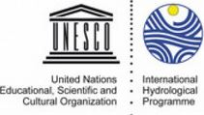
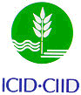

Who Should Attend?
- Local Authority Engineers and Planners
- Engineering Consultants, Researchers, Hydrologists, Environmental Engineers and Scientists
- Policy makers from all relevant fields
- Professionals involved with the implementation of the various EU water management Directives.

Conference Format .
The programme will consist of oral presentation of papers with discussion, and a poster / display session. Participants are invited to contribute through posters and oral presentations.

Call for Papers . .
Participants willing to contribute to the Conference through the presentation of a paper should submit a short abstract (maximum 600 words). The abstracts should be sent by e-mail to the Conference Secretariat by Friday, 28th July. The organising committee will review the abstracts and inform the successful authors by Thursday, 31st August.

Call for Posters ..
Participants willing to contribute through the provision of a poster display should submit a short summary (maximum 300 words) of the project or topic. The deadlines for submissions and the review and acceptance format and dates are as per the call for papers above.

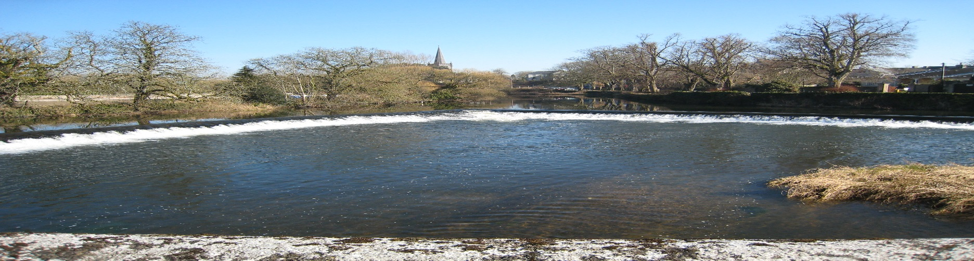
Irish National Hydrology
Conference 2017

Conference Booking & Costs .
Demand for places at previous Conferences has been high. Places are allocated on a first-come basis, and pre-booking is essential (using the registration form on this page). The cost of attendance at the Conference is €125 per person (with a limited Student rate of €40), which includes a Book of Proceedings on USB key, refreshments and lunch. Invoices will be issued following receipt of registration forms requesting the reservation of a place. Receipts will only be issued upon demand.

Conference Programme ..
The Programme for the Conference will be confirmed nearer the date. It is currently envisaged that the Conference will run from 10 a.m. to 4:30 p.m.

Registration / Further Information .
To register to attend the conference or to request further information, please complete the registration form and return (with payment to confirm a booking) to:

Contact: Oliver Nicholson,
Office of Public Works, Head Office,
Trim,
Co. Meath, Ireland.
Tel: 046 942 6737
E-mail: oliver.nicholson@opw.ie
All payments to be made by Electronic Fund Transfer (EFT)
BIC - DABAIE2D
IBAN - IE91DABA95167890052841
Please send remittance to receipts@opw.ie and reference the National Hydrology Conference.

Organisers
International Hydrological Programme (IHP) .
The UNESCO international scientific co-operative programme in hydrology and water resources, the IHP, was established to act as a catalyst to promote co-operation and research in the management of water resources, an issue which had been identified as a significant limiting factor for harmonious development in many regions and countries of the world.

International Commission on Irrigation and Drainage (ICID) ..
The mission of the ICID is to stimulate and promote the development of the management of water and land resources for irrigation, drainage, flood control and river training applications, including research and development and capacity building.

Registration Form
Name:
Job Title:
Organisation:
Address:
Purchase Order No. (if applicable):
Tel: Fax:
E-mail:
I would like to present a paper
I would like to present a poster

Title or explanation of Paper/Poster
I intend to participate without presentation
I wish to receive further information

